**Linear regression to predict the revised TOBT (target-off block time)**

In the given dataset [sampledata2], the difference between SOBT and TOBT is taken and a delta value is obtained. This delta value is the dependant variable in the regression equation y=b1(x) + b0.

Here x is the independent variable which is the critical path in the turnaround process. All the 6 critical paths are mathematically converted to one single variable.

B1 is the y-intercept and b0 is the slope in the given equation. The regression analysis is conducted in an excel sheet and we obtain the following graph.

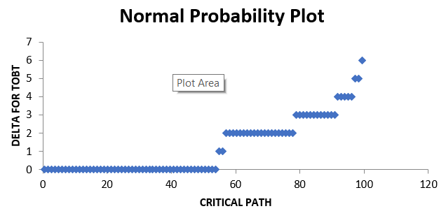

Y intercept obtained is 0.253781, and the slope obtained is 2.8135. When x value (critical path) is substitutes in the above equation with the above obtained y-intercept and slope we get a predicted outcome of the delta value of the revised TOBT. When these delta values are added to the existing TOBT we obtain the revised TOBT.